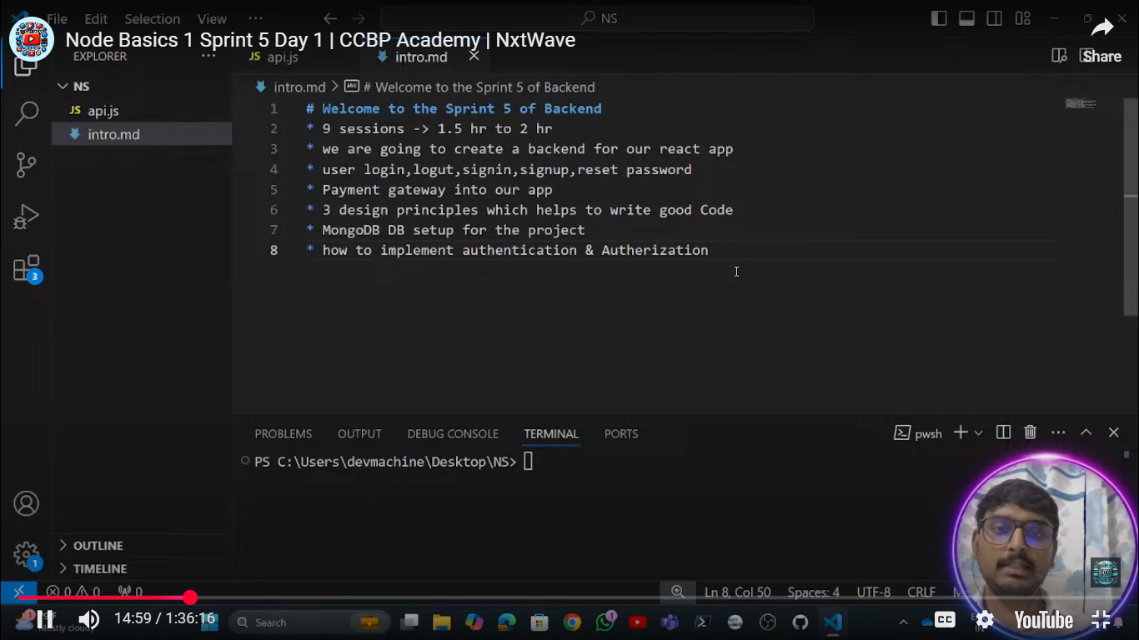

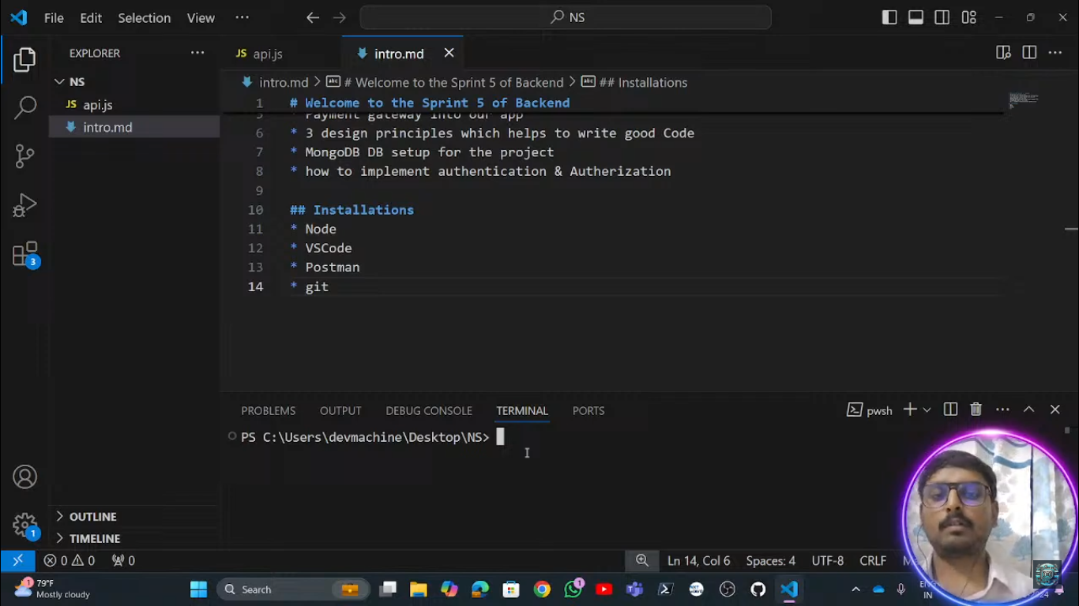

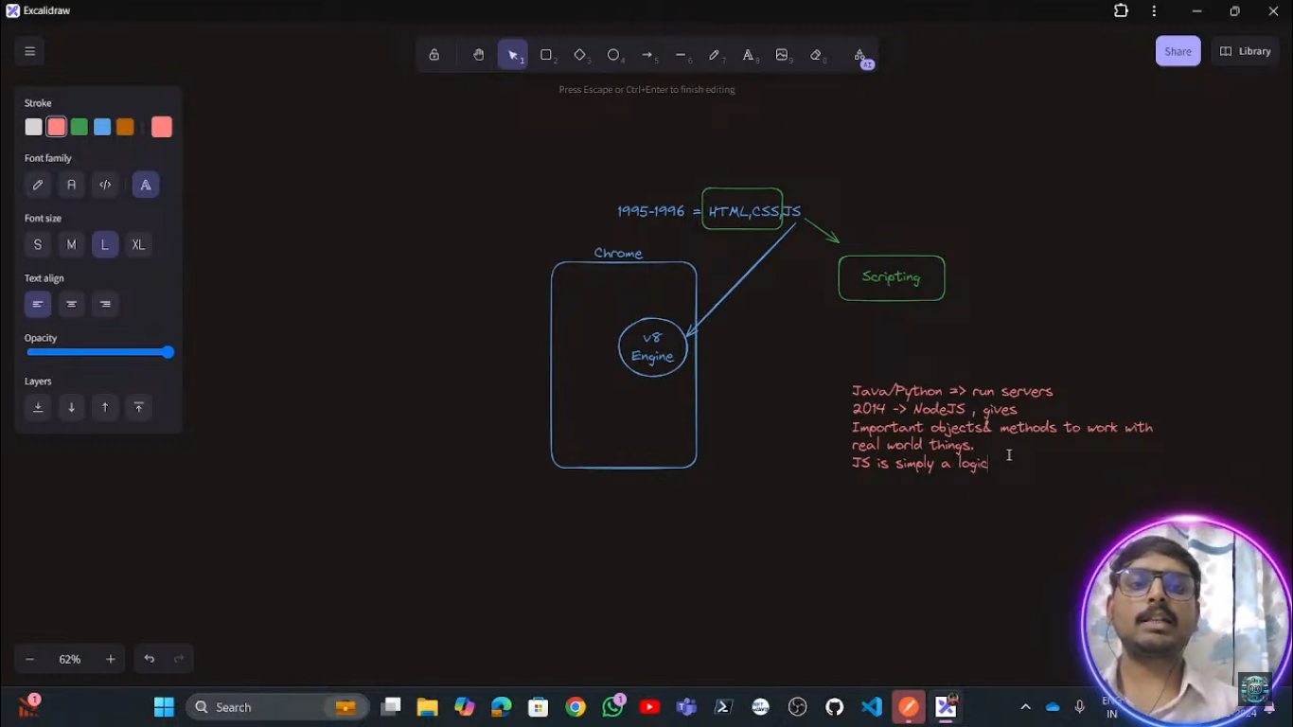

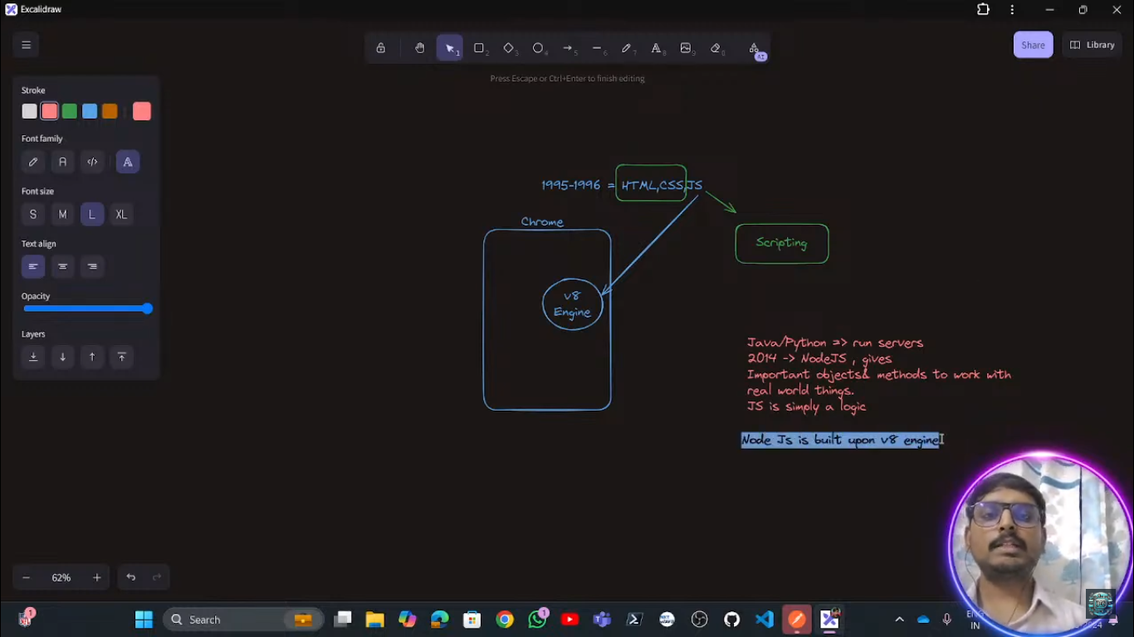

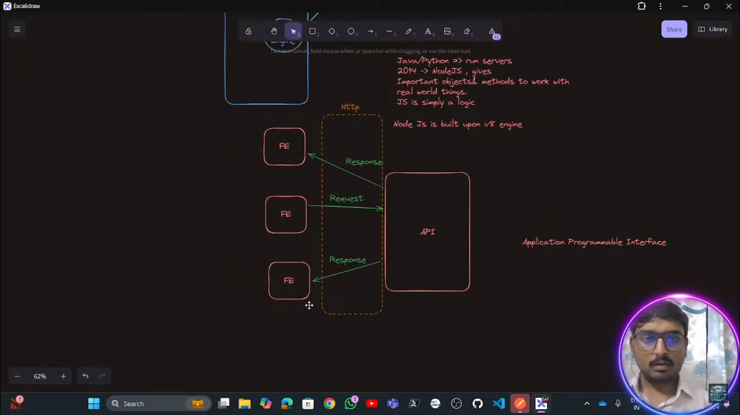

Here the Http is the intermediater between the front-end to backend to communicate between each-other and that http is the a module of the nodeJs .

And a express-Js a framework of nodeJs which is used to create a http sever

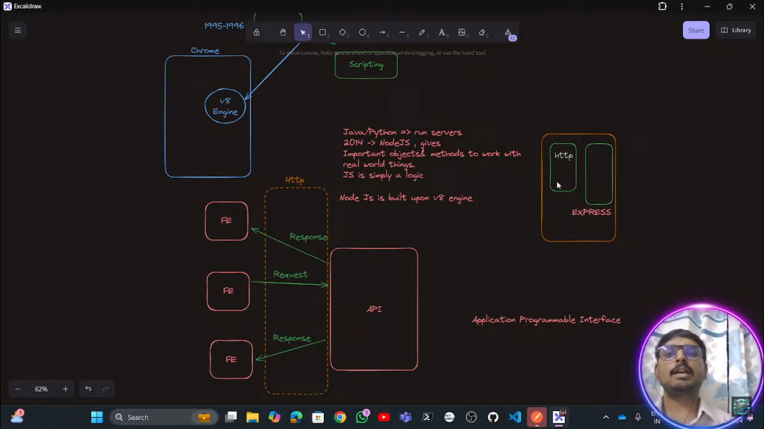

In order to create any node package we need to use the command as

npm init –y

## ****Breaking Down the Command****

* **npm** → The **Node Package Manager**, which is used to manage dependencies (libraries, frameworks, tools) in a Node.js project.
* **init** → Initializes a new Node.js project by creating a package.json file.
* **-y** → Skips the interactive questions and **automatically accepts default values** for the package.json file.

**Difference Between npm init and npm init -y**

| **Command** | **Description** |
| --- | --- |
| npm init | Starts an **interactive prompt** where you manually enter values (project name, version, description, etc.). |
| npm init -y | Skips the interactive prompt and **automatically generates a package.json file** with default values. |

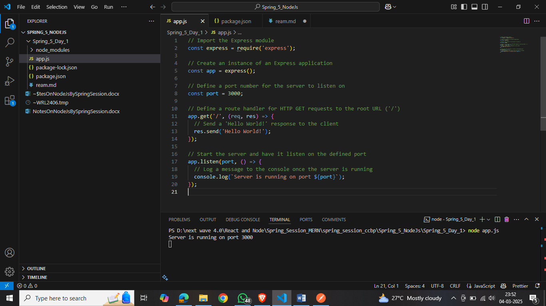

**Explanation:**

* **Import the Express module:** This line imports the Express module, which is a minimal and flexible Node.js web application framework that provides a robust set of features for web and mobile applications.
* **Create an instance of an Express application:** Here, we create an instance of an Express application by calling the express() function. This app object will be used to define routes and middleware for our application.
* **Define a port number for the server to listen on:** We specify the port number (3000) on which the server will listen for incoming requests.
* **Define a route handler for HTTP GET requests to the root URL ('/'):** This line sets up a route handler that listens for GET requests to the root URL ('/'). When such a request is received, the provided callback function is executed.
* **Send a 'Hello World!' response to the client:** Within the callback function, we use the res.send() method to send the string 'Hello World!' as a response to the client.
* **Start the server and have it listen on the defined port:** The app.listen() method starts the server and makes it listen for incoming connections on the specified port.
* **Log a message to the console once the server is running:** Once the server is up and running, the callback function passed to app.listen() is executed, logging a message to the console to indicate that the server is operational.

This code sets up a basic Express.js server that responds with 'Hello World!' when a GET request is made to the root URL. For more information and examples, you can refer to the official Express.js documentation.

<https://developer.mozilla.org/en-US/docs/Learn_web_development/Extensions/Server-side/Express_Nodejs/Introduction>

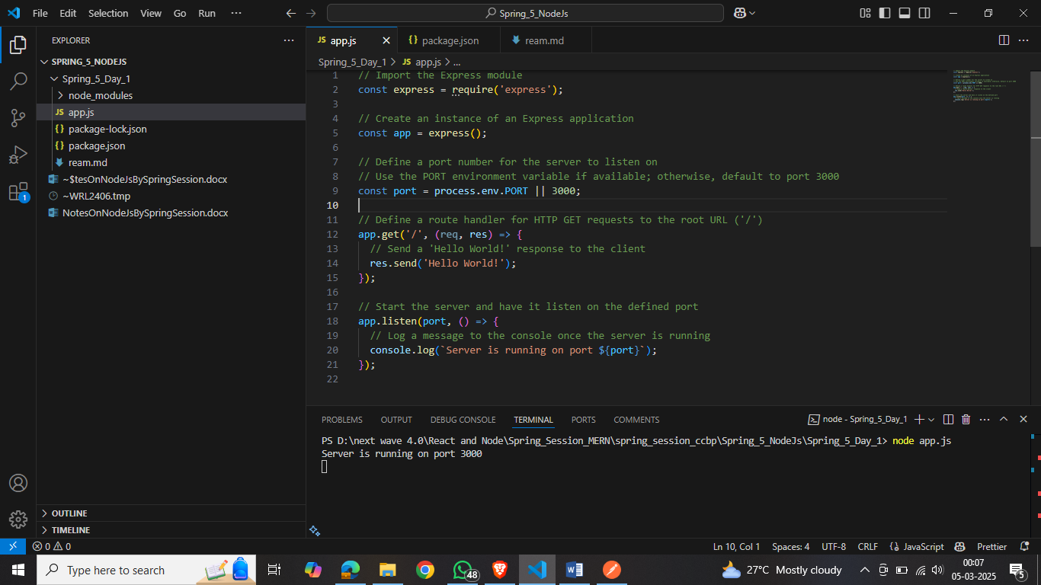

In this example:

* process.env.PORT retrieves the port number set by the environment.
* If process.env.PORT is undefined, the server defaults to port 3000.

**Benefits of Using process.env.PORT:**

* **Flexibility:** Allows the application to adapt to various environments without code modifications.
* **Compatibility:** Ensures the application listens on the port specified by hosting providers, which may assign ports dynamically.
* **Avoiding Conflicts:** Reduces the risk of port conflicts when multiple applications run on the same server.

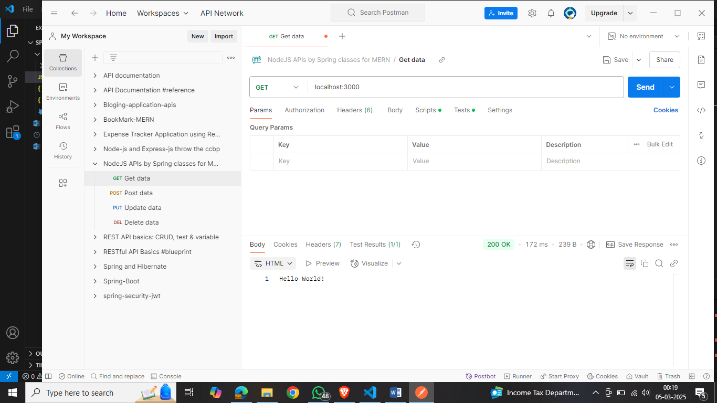

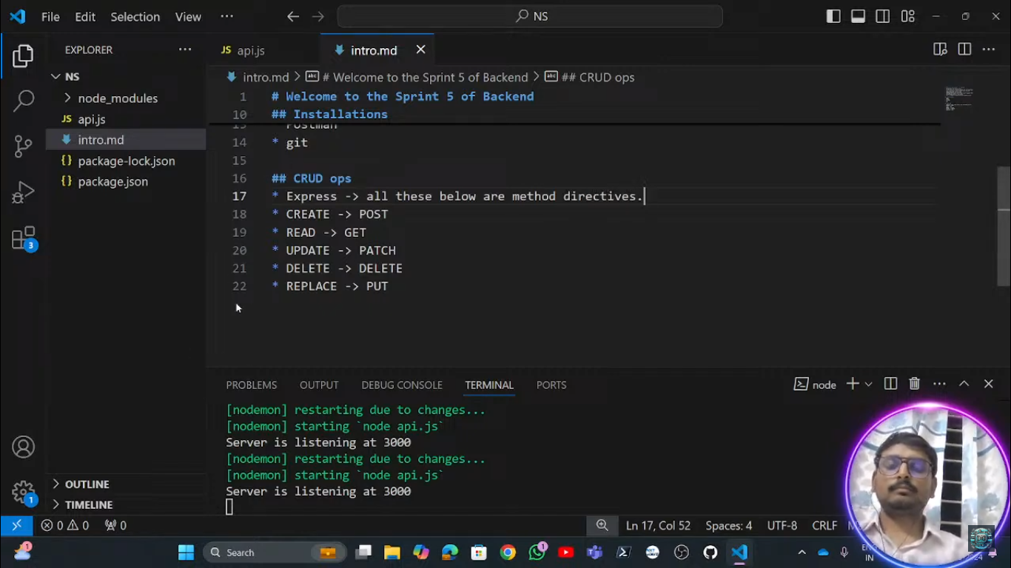

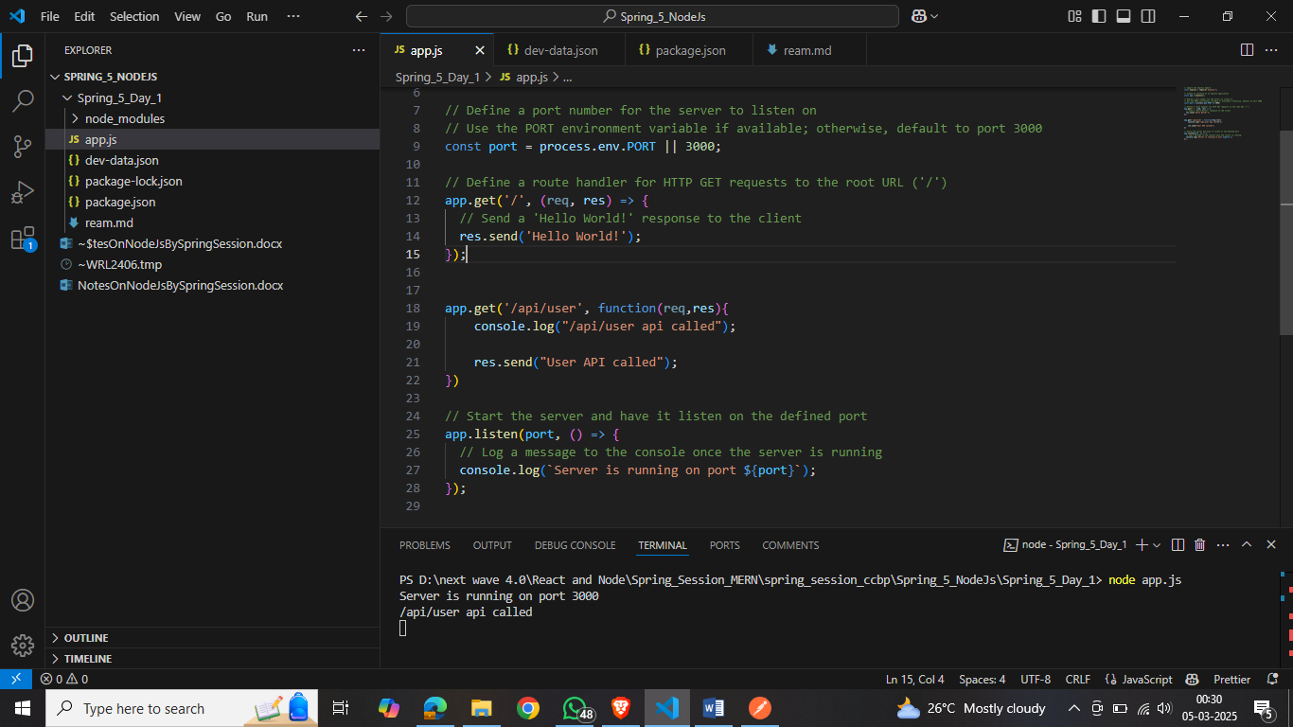

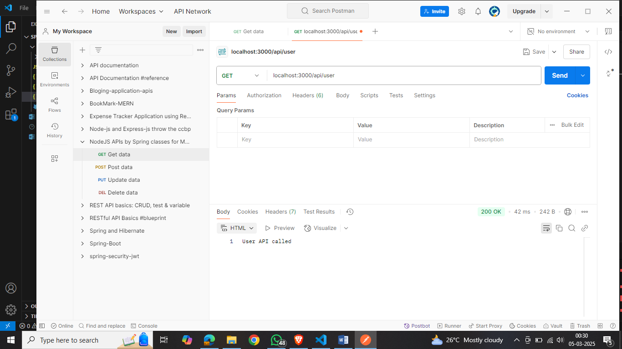

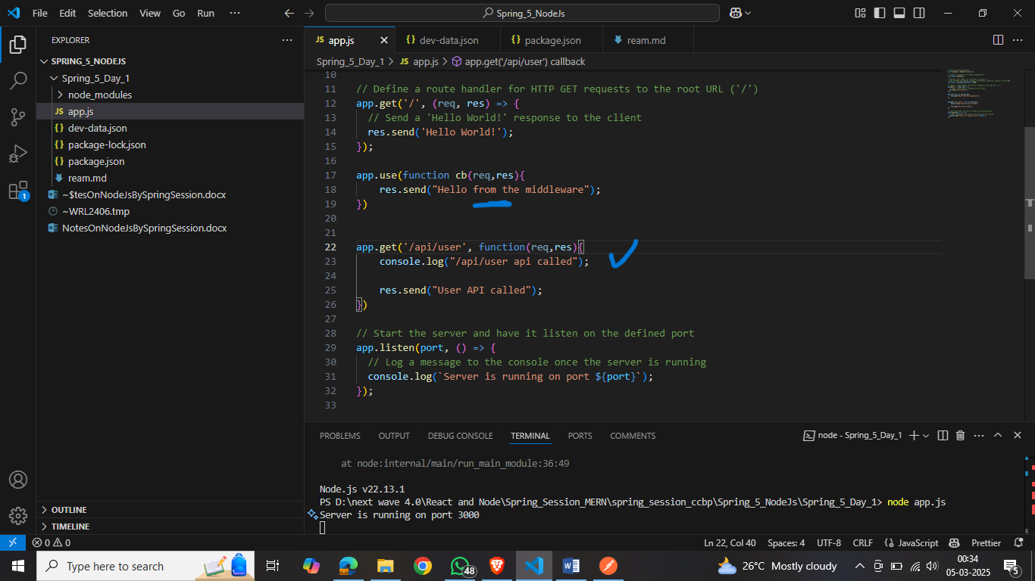

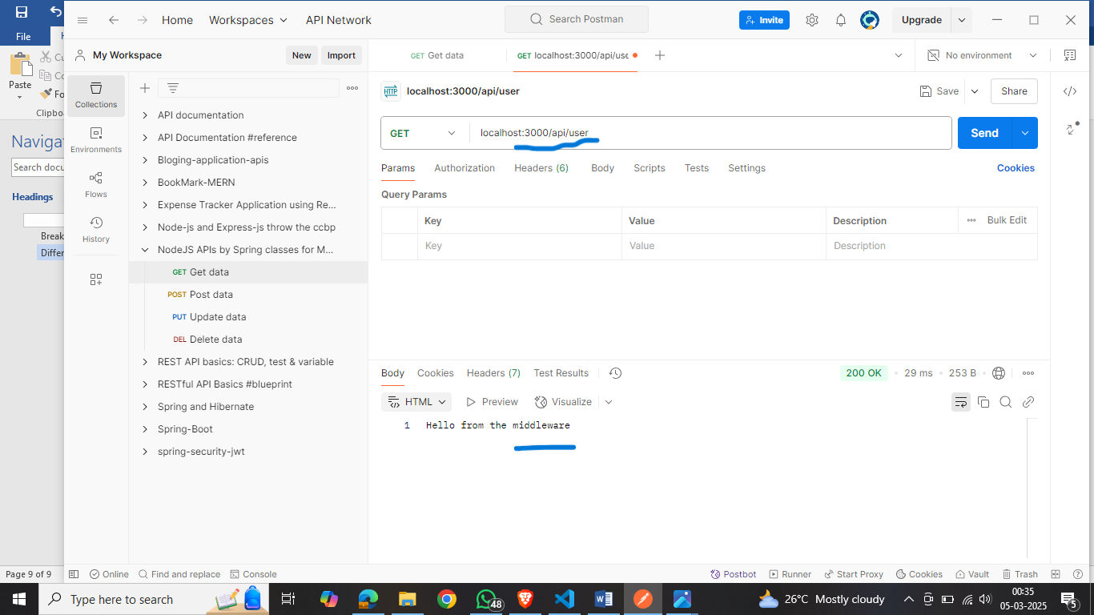

Here we are not getting the currect respose because

In Express.js, middleware functions are executed in the order they are defined. citeturn0search2 This sequential execution means that if a middleware function sends a response without calling next(), subsequent middleware and route handlers won't be executed.

In your code, the middleware function defined by app.use(function cb(req, res) { res.send("Hello from the middleware"); }) is placed before the /api/user route handler. When a request matches this middleware, it sends a response and doesn't call next(), preventing the /api/user route handler from being reached.

**Solution:**

To ensure that the /api/user route handler is executed, you should place the middleware function after all route handlers or modify it to call next() so that the request can proceed to the next matching route. Here's how you can adjust your code:

**Option 1: Move the Middleware After Route Handlers**

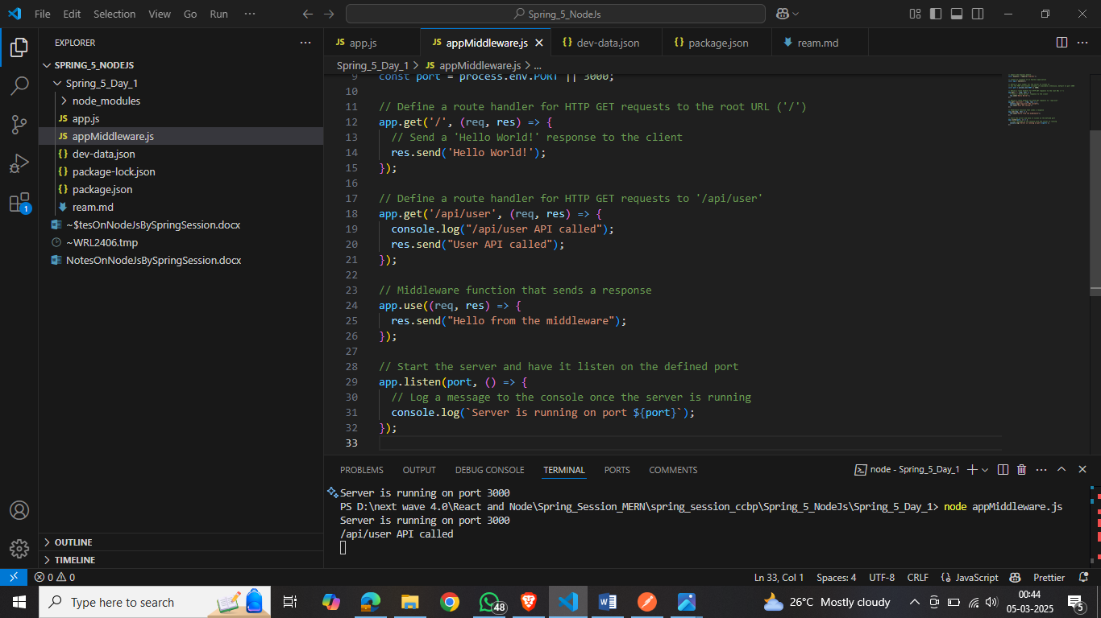

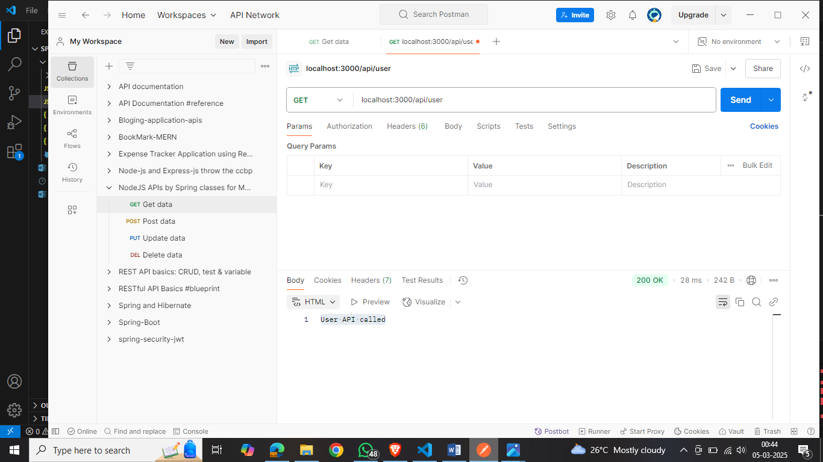

**Option 2: Modify the Middleware to Call next()**

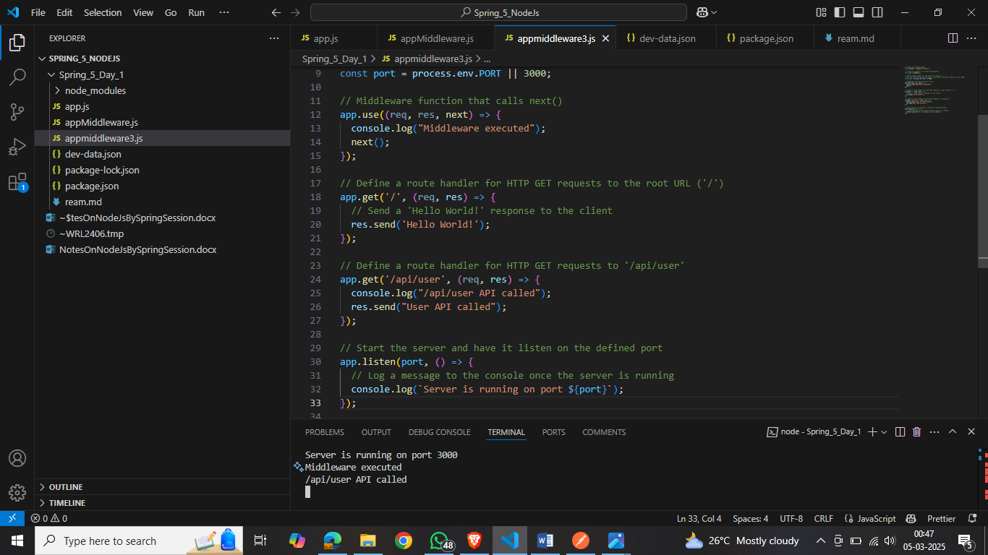



By either moving the middleware function after the route handlers or ensuring it calls next(), you allow the /api/user route handler to be reached and executed as intended.

---------------------------------Dy02------------------

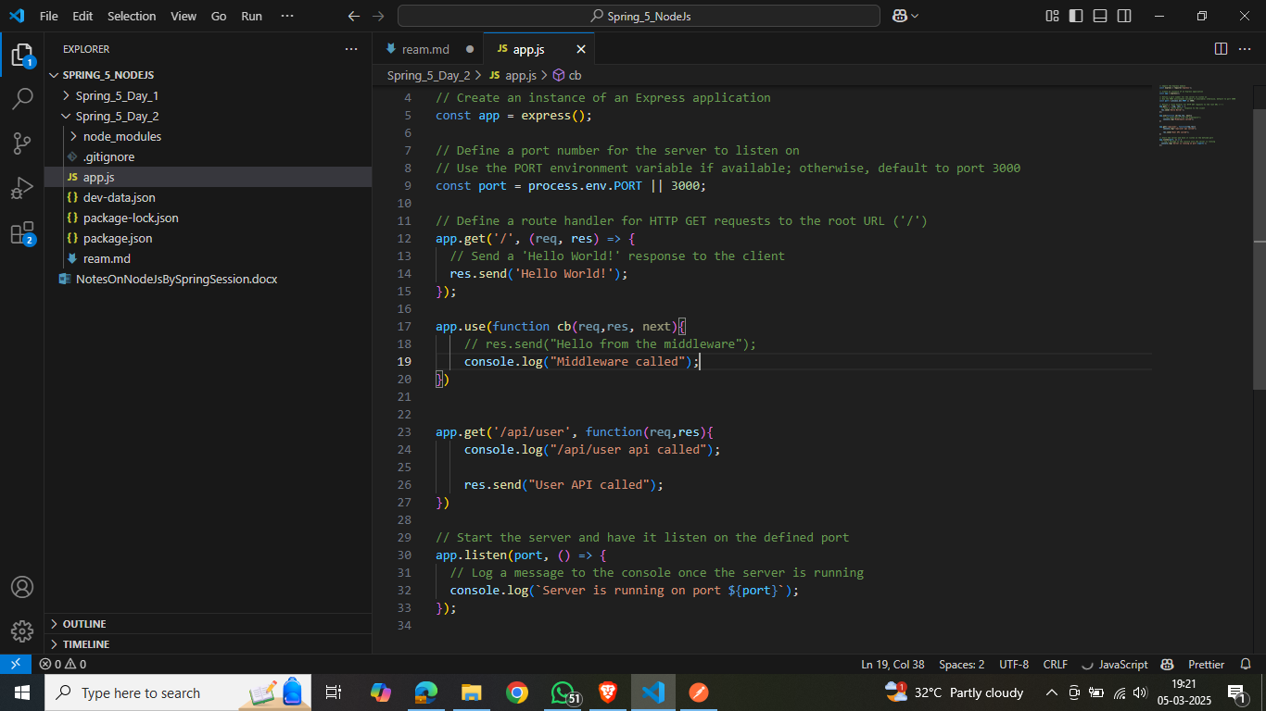

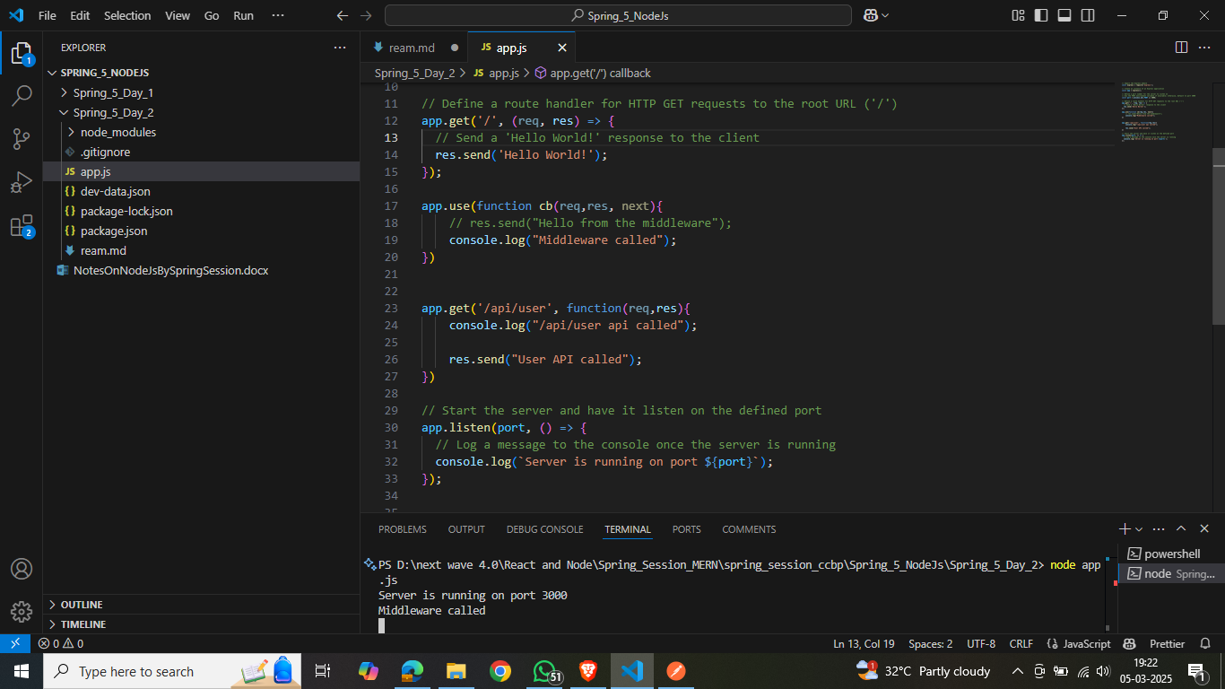

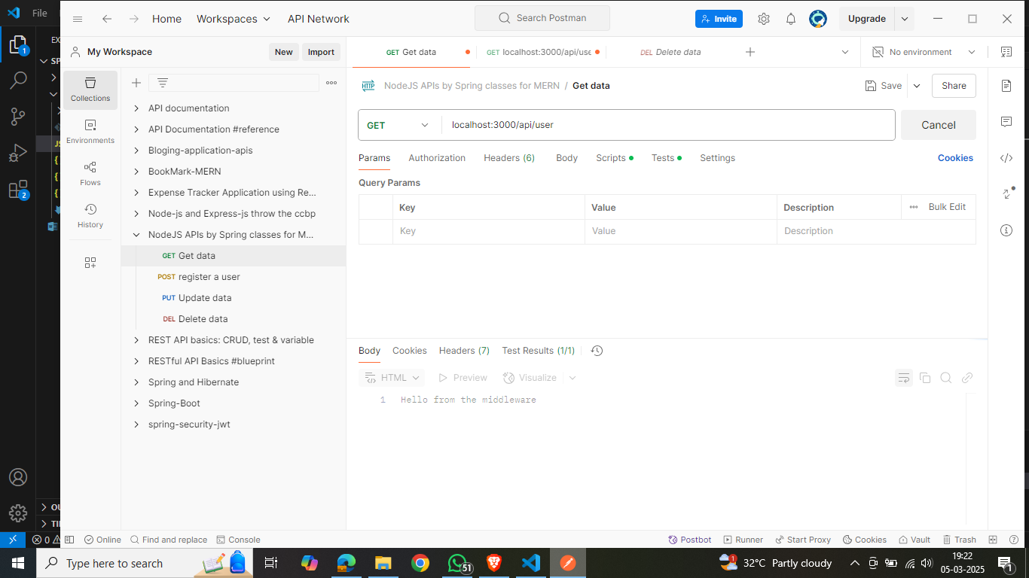

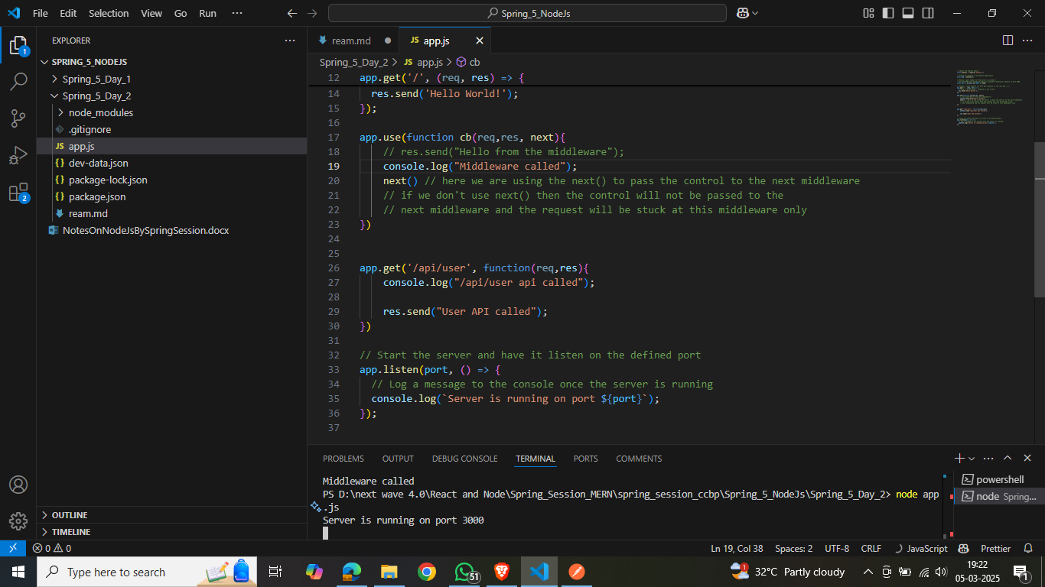

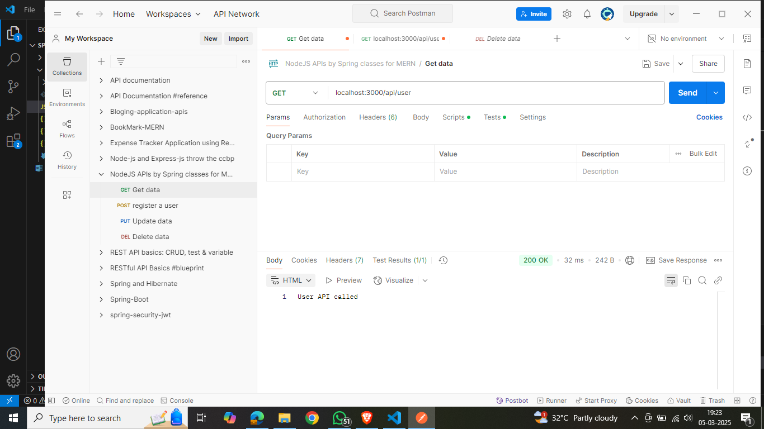

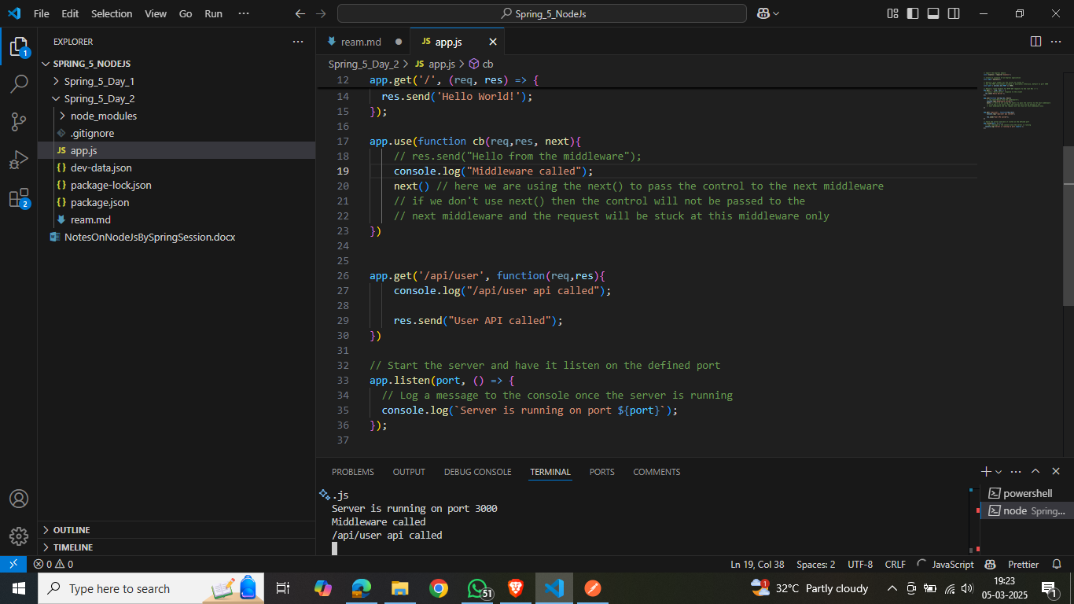

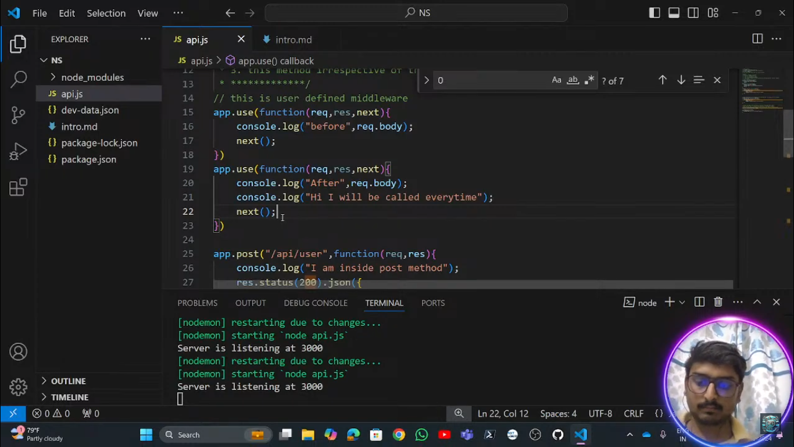

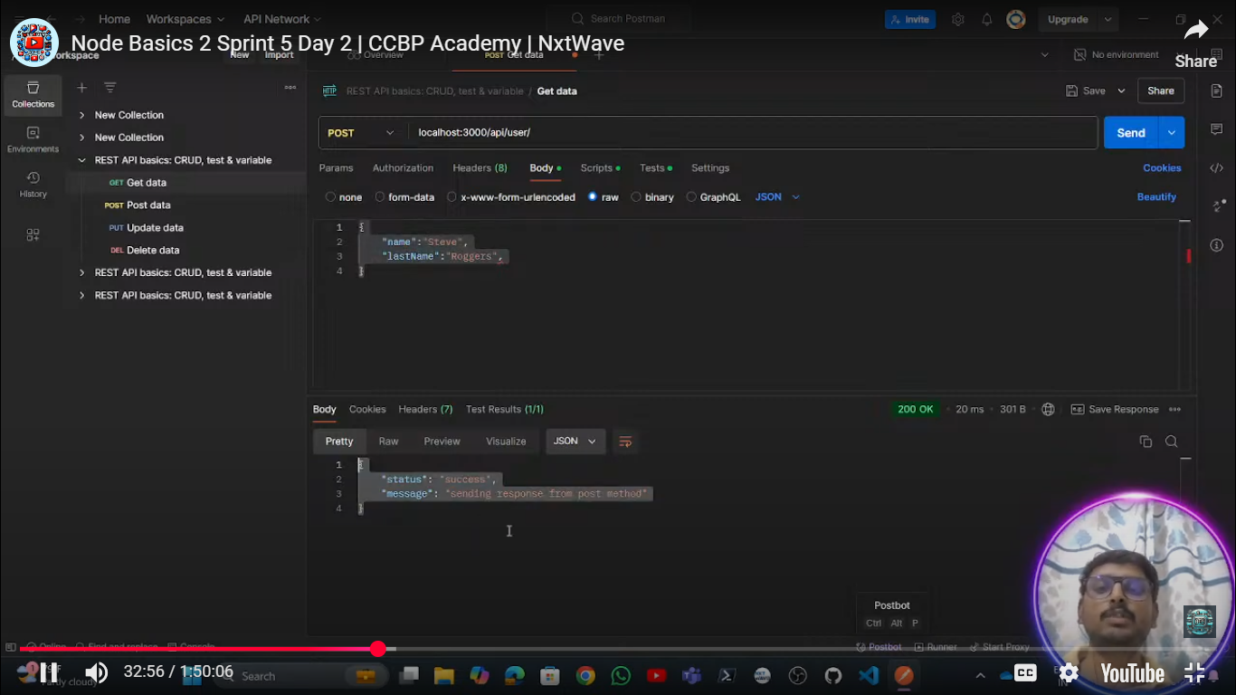’

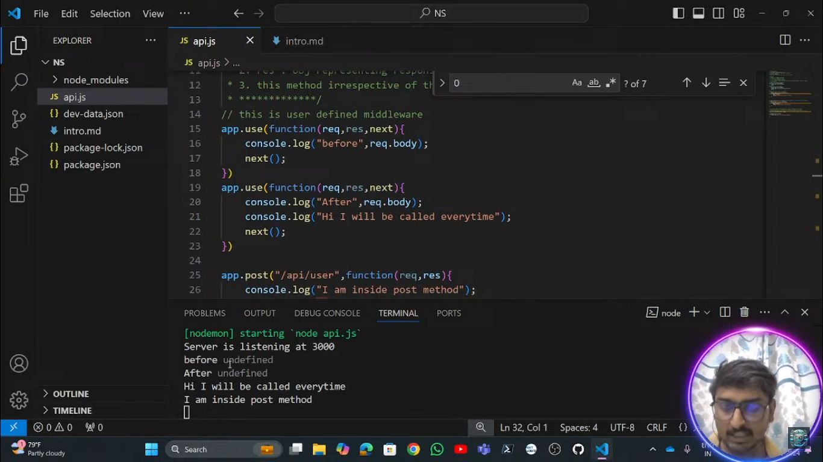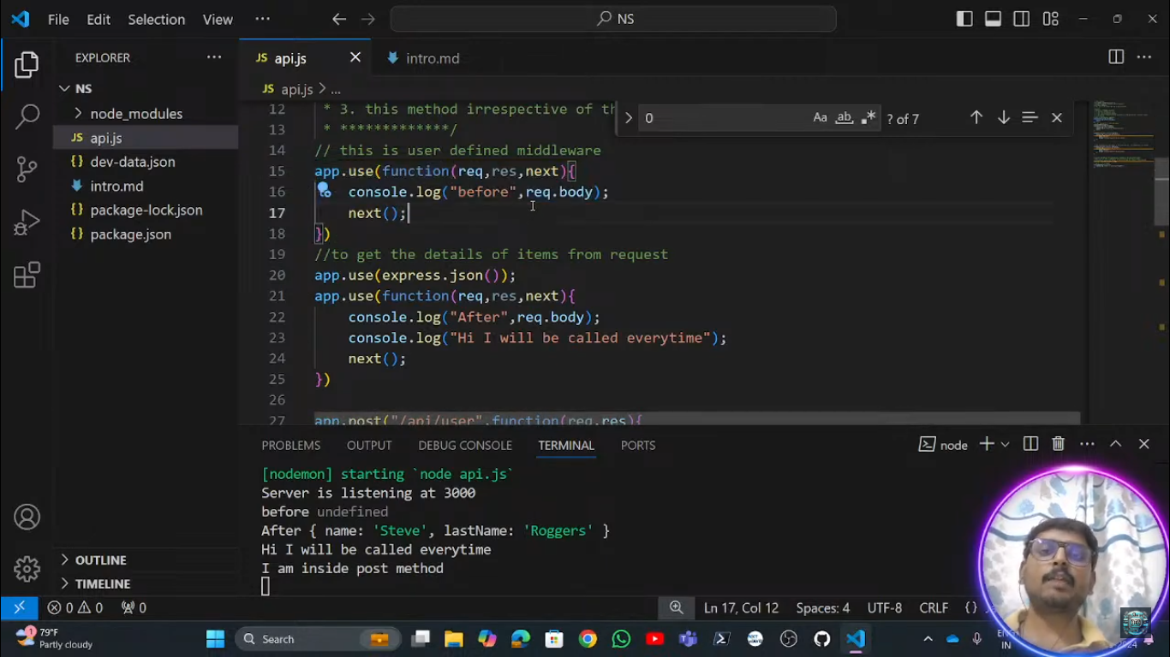

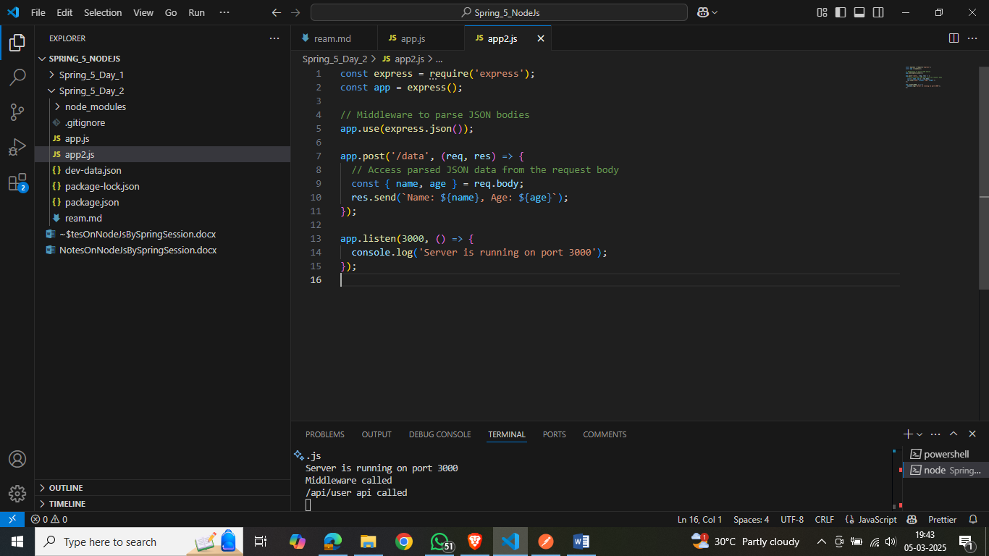

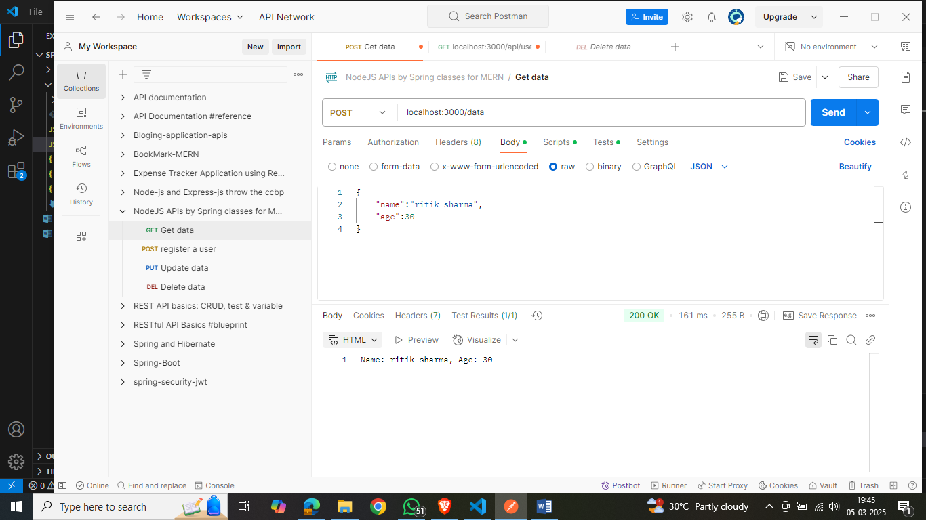

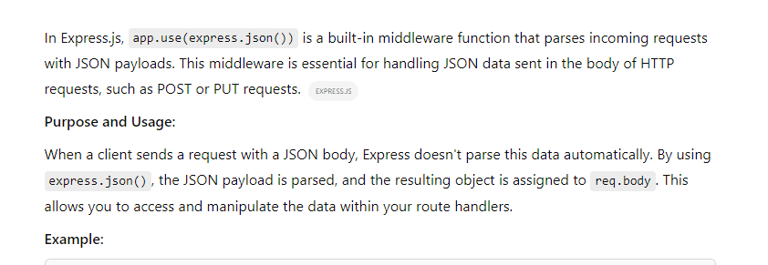

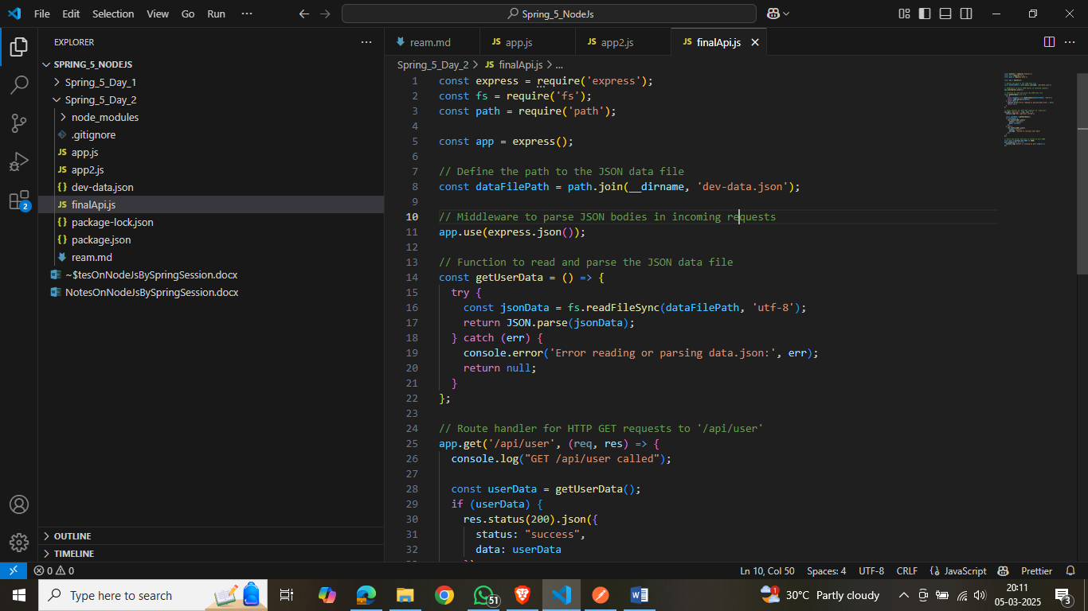

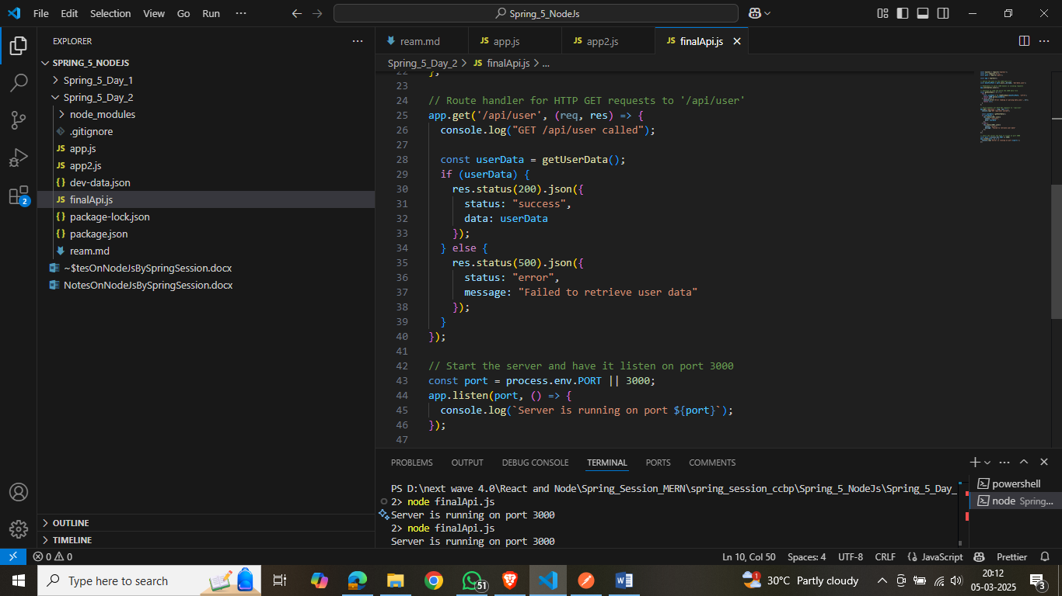

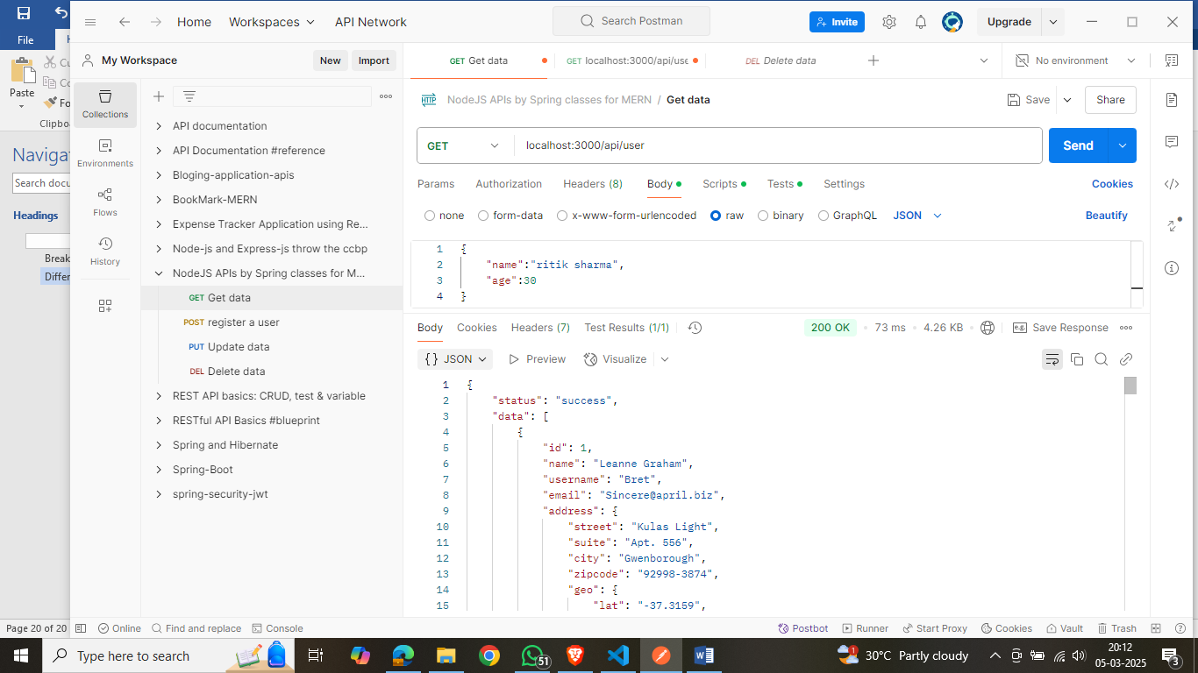

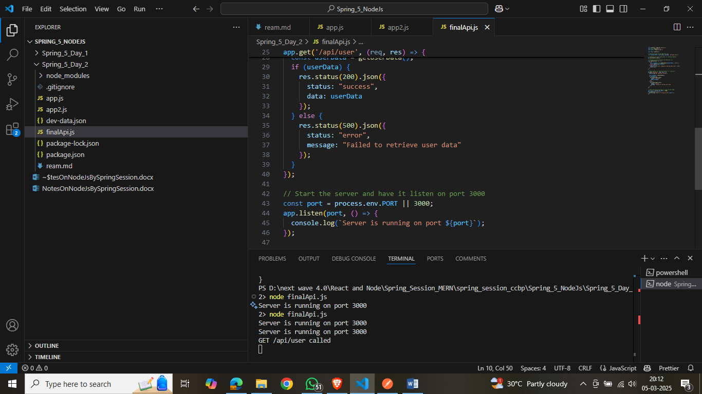

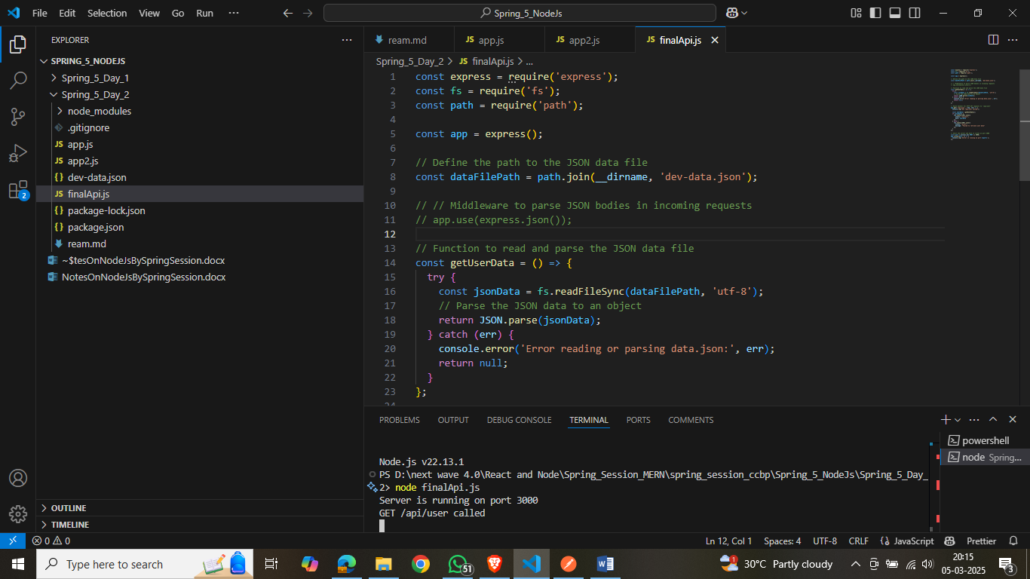

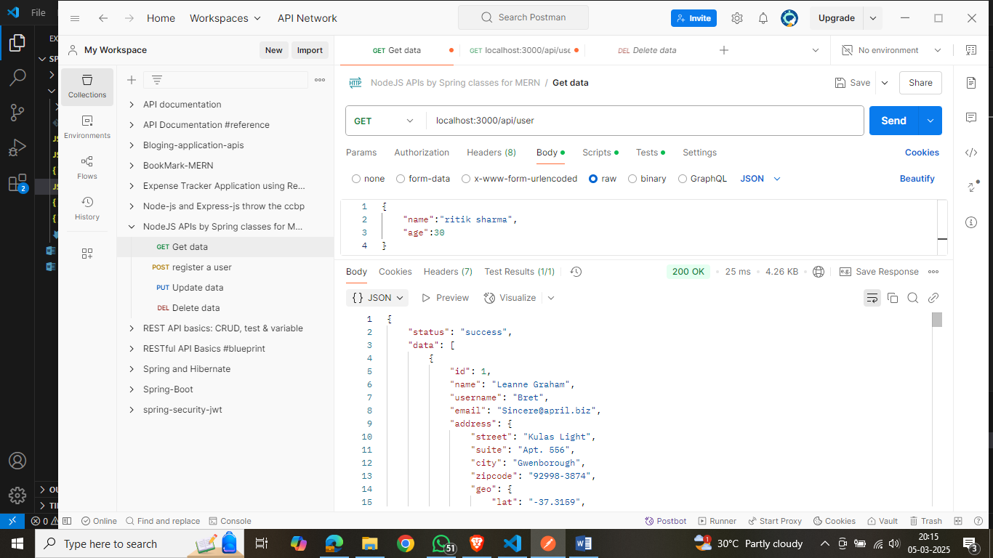

Here without use of app.use(express.json());

We are able to see the data in json format beasue we have to use this when we are getting the data from the request and convert it into json but here we are sending the json not getting from reuest we are responding here.

Day-3:

We covered the following things in this unit:

1) Intro to MVC architecutre & its uses

2) Implementing MVC architecture

3) Refining the code with factory Design pattern

4) Intro to DB, Types of DB